Computer

Name: Ibrahim rashed Ibrahim Ibrahim

B.N/ 8

Date : 30/5/2020

Topic: cryptography

Gitup address:

# Application:

Cryptography is the science of information security. The word is derived from the Greek kryptos, meaning hidden. Cryptography includes techniques such as microdots, merging words with images, and other ways to hide information in storage or transit. Modern cryptography intersects the disciplines of mathematics, computer science, and electrical engineering. Applications of cryptography include ATM cards, computer passwords, and electronic commerce.

Cryptography has been used for many years. Its main goal is to make sensitive information unreadable to all but the intended recipient. There are so many methods that once were popular for hiding this sensitive data.However researchers and cryptanalysis succeeded

to attack the secrecy of a number of these methods.The cryptographic keys must be established

between the sender and the receiver eithermanually or using trusted third party key

management.

Many authors have compared the algorithms on the basis of time complexity and space complexity. This paper compares these algorithms on the basis of parameters like key length and management,security and limitations pertaining to each algorithm.

Cryptography is the science of writing in secret code and is an ancient art. It is no surprise,then, that new forms of cryptography came soon after the widespread development of computer communications. In data and telecommunications,cryptography is necessary when communicating over any untrusted medium, which includes just about any network, particularly the Internet. Withinthe context of any application-to-application communication, there are some specific security requirements, including:

* Authentication: The process of proving one'sidentity.
* Privacy/confidentiality: Ensuring that no one can read the message except the intended receiver.
* Integrity: Assuring the receiver that the received message has not been altered in any way from the original.
* Non-repudiation: A mechanism to prove that the sender really sent this message.

# Screenshots:

# 

# 

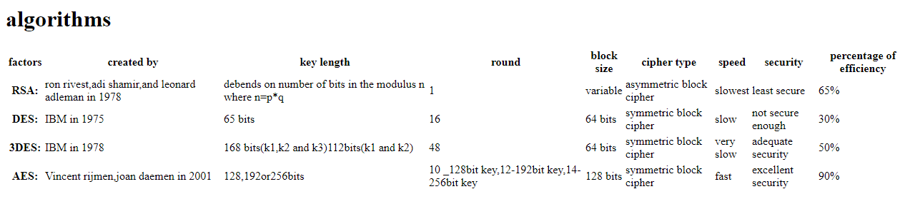

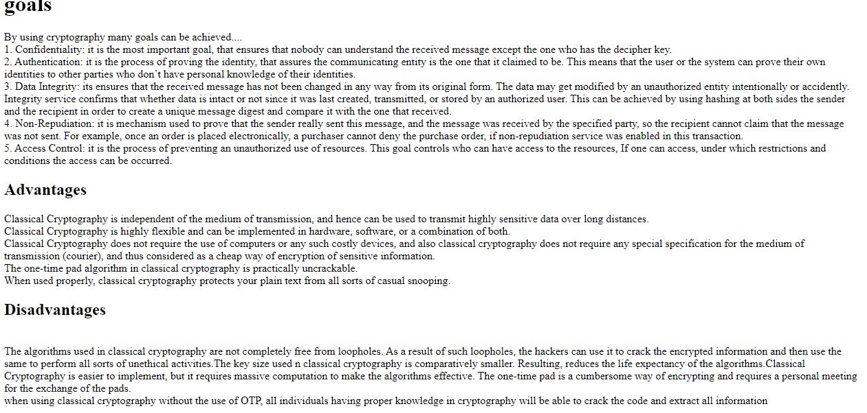

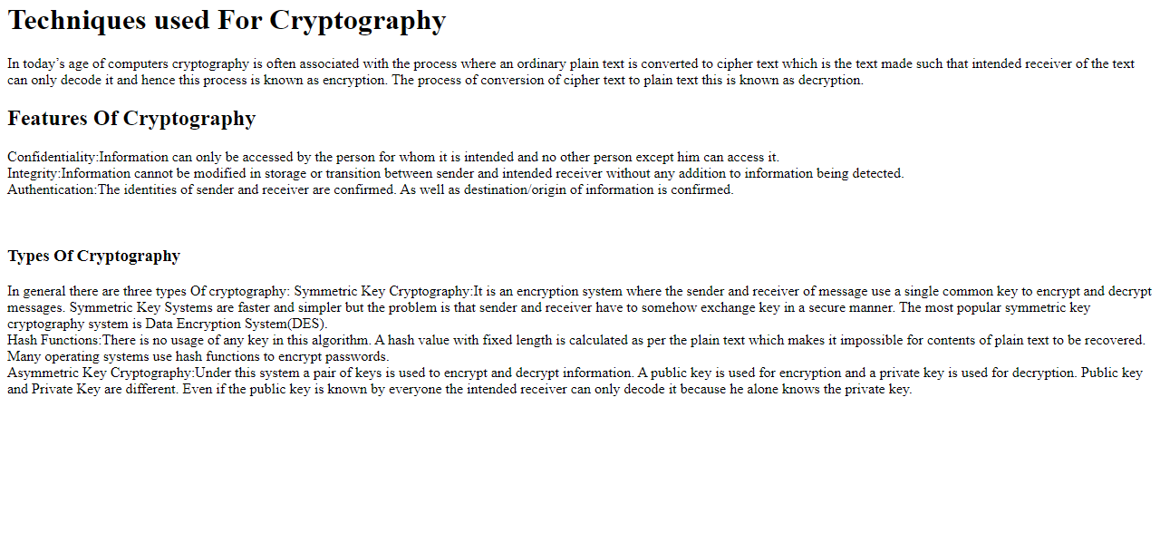

## Source code:

`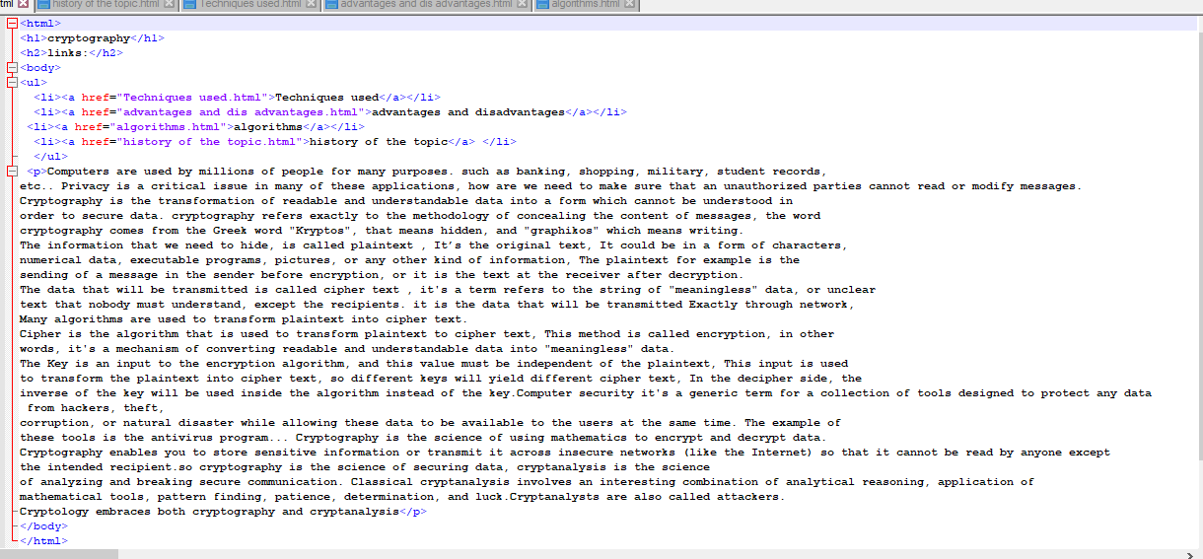

# Reference:

* <https://www.mathematik.uni-kl.de/~ederc/download/Cryptography.pdf>
* <https://www.researchgate.net/publication/276317739_Cryptography/citation/download>
* <https://www.pdfdrive.com/understanding-cryptography-d19606679.html>